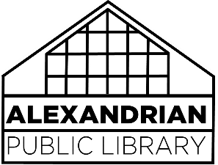programs & services cancellation Policy

In the case of inclement weather, programs or services at the Alexandrian Public Library may need to be suspended or cancelled for the safety and security of APL staff and patrons traveling to the library.

If the MSDMV Vernon schools CLOSE, morning programs and storytimes will be automatically cancelled.

If the MSDMV schools DELAY opening, morning programs and storytimes will be automatically cancelled.

In the case of a delay, closure or early release of schools due to weather, afternoon programs may be affected as well. Patrons are instructed to contact the library the day of an afternoon program to inquire if a program will still be held. Decisions regarding afternoon programming will be made no later than noon by APL staff members. The library phone number to inquire about programs is 838-3286.

Depending upon the weather conditions, the library vehicles (both the Bookmobile and delivery van) may be off of the road for part, or all of the day when:

* Extreme Cold Notification – the weather forecast calls for temperatures below 10 degrees, including the wind chill.
* Extreme Heat Notification – the weather forecast calls for a temperature exceeding 95 degrees, including the heat index.

Other inclement weather conditions that would result in hazardous driving conditions for library vehicles are as follows:

* Packed snow or ice on the roads or snow in excess of three inches
* Sleet, freezing rain, heavy rain, or flooding on the roads
* A Winter Storm or Tornado Warning, issued by the National Weather Service
* Dense fog with visibility less than ¼ mile
* Wind gusts that exceed 40mph or high wind warnings

Under the judgement of the vehicle driver, stops and/or service may terminate early due to weather.