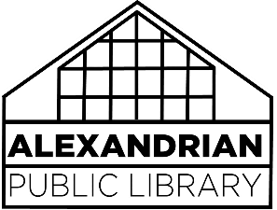materials selection Policy

It is the function of the Alexandrian Public Library to provide materials for all ages, from preschool through maturity. Each title is judged individually according to its intrinsic merit, the subject matter treated, interest, and the contribution of the material to the established collection. Each work is judged as a whole, and isolated passages in themselves are not used as criteria. The materials selection policy reflects the mission of the library:

*The Alexandrian Public Library is the primary provider of information resources and services for enriching the lives of residents of Posey County and the surrounding area.*

Because the library serves clients from a diverse array of ages, backgrounds, ethnicities and beliefs, its collections will naturally reflect this diversity. Moreover, representative democracy is strengthened by encouraging citizens to range widely throughout the free marketplace of ideas. No one will agree with all ideas in this marketplace, and almost everyone will deem some of the ideas found here repellant. It must be emphasized that the purchase of materials by the library does not constitute endorsement of a particular viewpoint or belief by the library.

The Board delegates responsibility for the selection of materials to the Director, who appoints individuals from the staff to select materials for specific collections. The Coordinators of Adult, Children’s and Bookmobile Services exercise guidance over the material selection of the entire library system. The staff consults a variety of professional reviewing resources.

Materials within the library collection are continuously monitored. Items may be withdrawn if they contain outdated or inaccurate information, are superseded by a newer edition, are worn or badly marked, are duplicates, or are seldom used materials. Space, replacement costs and the quality and appearance of the collection are factors in this decision.

The Trustees of the Alexandrian Public Library endorse the *Library Bill of Rights* as adopted by the American Library Association Council in 1948 and amended in 1961, 1967, and 1980. However, patrons may ask collection managers to review materials contained within the library collection based on the standards contained within this document. They will be asked to fill out the “Request for Reconsideration of Library Materials” form, detailing the nature of their challenge and what action they would like the library to take.

Details on the library roles for services, selection criteria, areas of collection, weeding and requests for reconsideration may be found in our “Collection Development Plan and Procedure”.