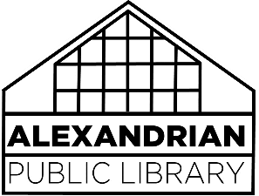FOOD AND DRINK Policy

The Alexandrian Public Library strives to create a welcoming, clean, and comfortable environment for the public while maintaining the equipment, furniture, and collections within. Consistent with this goal, the following guidelines have been adopted for the consumption of food and drink within the library:

* Food and nonalcoholic beverages may be consumed in all meeting spaces.
* Food and lidded nonalcoholic beverages are permitted throughout the library, except when in close proximity to technology (public computers, scanners, etc.) or Indiana Room materials.

Library staff may, at their discretion, ask a patron to refrain from drinking or eating, to move their drink or snack, or ask the patron to dispose of said items if the staff believes library materials or equipment is in jeopardy of being damaged. In the event of damage from food or drink, costs may be assessed to the responsible patron.

Food and drink is permitted in the study rooms, but private events at which food will be served for a group must rent either the Ohio or Wabash room to accommodate their event.

Food and drinks as part of a special event within the library will be permissible at the discretion of the Director.