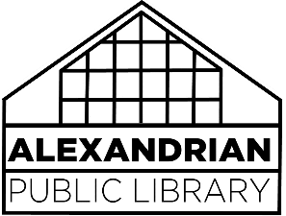Author-Provided titles and programs policy

APL is occasionally contacted by an author who wants us to add their book to our collection by either purchase or donation. APL requests that the author send us a complimentary review copy that will not be returned regardless of our decision. Once a review copy has been received, it will receive due consideration like any other title (seeking positive reviews, product potential, local interest or a complete reading of the title, for example). Many titles often do not fit our needs.

If APL wishes to purchase a copy, we will attempt to do so through our contracted vendors, then through secondary vendors, then through the publisher. Only if we can’t make contact with the publisher will we contact the author directly for purchase. We do not provide authors with reviews or critiques, nor will we engage in conversation to explain our decision. Titles that have been added to the collection are also subject to the same weeding procedures as all titles in our collection, regardless of local connection or author provision.

If someone from APL contacts the author regarding a program, it will be considered a sanctioned APL event with all due promotion and planning. If the author chooses to host a program or book signing without APL’s involvement, all meeting room charges and requirements will apply. The hosting of their own program does not guarantee the author that their book will be added to the collection through purchase or donation.

In the case of an APL-sponsored event, the author will be required to provide all titles for purchase or book signing following the planned event. Each author will be required to either provide a book reading, a discussion, a question-and-answer period or some other type of audience-attended program, rather than just a purely profitable program for the author. After the program presentation, Treasures gift shop may choose to sell the title for up to two months.