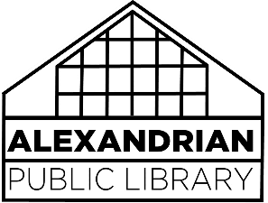SOCIAL MEDIA Policy

The Alexandrian Public Library maintains a presence on a variety of social media platforms to encourage community involvement in the library, to create a dialogue between the library and patrons, and to promote library-sponsored events and activities.

Program participants should expect that photographs/video will be taken at events and used on the library’s social media sites, publications and/or website. The library will not identify members of the public in social media posts without accompanying text or photograph highlighting within the platform itself (typically called “tagging”) without verbal or written consent. The library is not responsible for members of the public being identified by third parties either in comments or by tagging. If the subject is under 18 years old, consent must be given by the parent or legal guardian.

Comments and postings from the public are allowed, but will be reviewed by library staff for content. Patrons are expected to follow the basic rules of civility, and the library reserves the right to remove any patron-contributed content that violates the APL Appropriate Behavior Policy.

The library does not endorse the advertisements promoted on any social media site. These advertisements are displayed by vendors and do not express the library’s view or opinions.