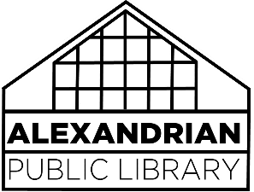Challenged Materials and Censorship Policy

The Trustees of the Alexandrian Public Library endorse the *Library Bill of Rights* as adopted by the American Library Association Council in 1948 and amended in 1961, 1967, and 1980. It reads as follows:

The American Library Association affirms that all libraries are forums for information and ideas, and that the following basic policies should guide their services.

1. Books and other library resources should be provided for the interest, information, and enlightenment of all people of the community the library serves. Materials should not be excluded because of the origin, background, or views of those contributing to their creation.
2. Libraries should provide materials and information presenting all points of view on current and historical issues. Materials should not be proscribed or removed because of partisan or doctrinal disapproval.
3. Libraries should challenge censorship in the fulfillment of their responsibility to provide information and enlightenment.
4. Libraries should cooperate with all persons and groups concerned with resisting abridgment of free expression and free access to ideas.
5. A person’s right to use a library should not be denied or abridged because of origin, age, background, or views.
6. Libraries which make exhibit spaces and meeting rooms available to the public they serve should make such facilities available on an equitable basis, regardless of the beliefs or affiliations of individuals or groups requesting their use.