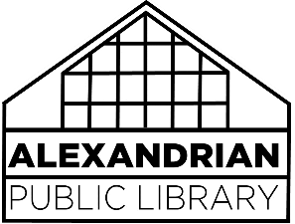
DONATED MATERIALS Policy

Donated materials are welcomed and encouraged by the library. All donated materials become the property of the Friends of the Alexandrian Public Library if items are not added to the collection. Materials are accepted with the understanding that they may or may not be added to the collection. If not needed, they may be sold or given away.
Receipt Forms will be provided for those patrons wishing to deduct their donations for tax purposes. The Library does not provide appraisal of donations for income tax or other purposes.

