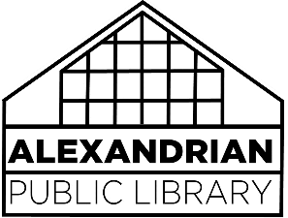
SMALL GROUP
MEETING ROOM Policy

The Alexandrian Public Library provides small group meeting space free of charge. The fact that a group is permitted to meet at the Library does not in any way constitute an endorsement of the group’s policies and beliefs by the Library.
1. Reservations: Library-sponsored and library-related meetings and programs will receive preference when scheduling is done. Any patron aged 14 and older may reserve a small group meeting room (Meeting Room A, Meeting Room B, Meeting Room C) for up to three hours. Time may be extended at the discretion of APL staff if no other groups are waiting. The patron reserving the room will be responsible for the room and the equipment.
The small group meeting rooms may be reserved up to three months in advance. Patrons must check in at the Information Desk to confirm use of the meeting room and request access to the room by a staff member. Patrons are requested to also let staff know when they are finished with the meeting room.
2. Walk-In Usage: When there is no reservation for a small group meeting room, they will be available on a first-come, first-served basis to any patron aged 14 or older for up to three hours. Time may be extended at the discretion of the APL staff if no other groups are waiting. The patron reserving the room will be responsible for the room and equipment.
Walk-in patrons must check in at the Information Desk to use a meeting room and request access. Patrons are requested to also let staff know when they are finished with the meeting room.
3. Available Hours: The rooms may be used during open hours, but meetings may not be scheduled during days the library is closed or after regular library hours. In the event of an emergency closing of the library, any scheduled meetings are automatically cancelled. If you are unsure of a closure, please call APL at (812) 838.3286.
4. Capacity and Equipment: Chairs, a table, and power/data plugs are available for use, as well as a mounted monitor in Meeting Rooms A and B. The Library is not responsible for equipment, supplies, or other items owned by a group or individual and may not be stored at the library. Food and drink are permitted, but patrons are requested to dispose of trash accordingly and be respectful of the space. Capacities for each space:
- Meeting Room A: 8
- Meeting Room B: 4
- Meeting Room C: 8

